Reactive account flow

User flow
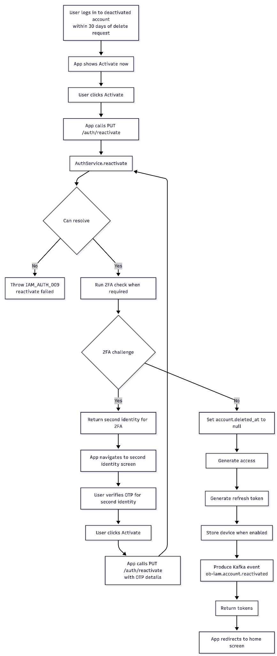

Preview Screen
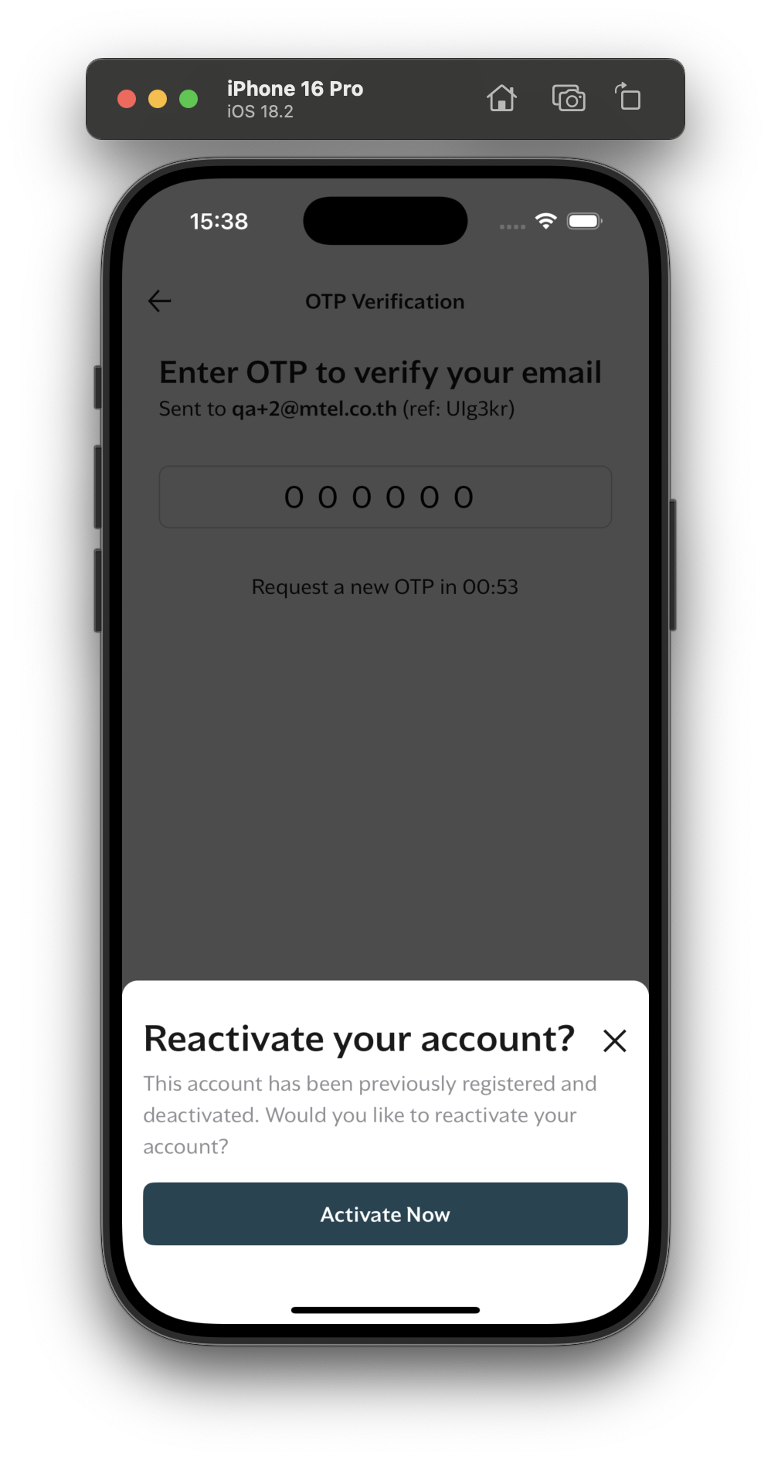

Sequence diagram- IAM
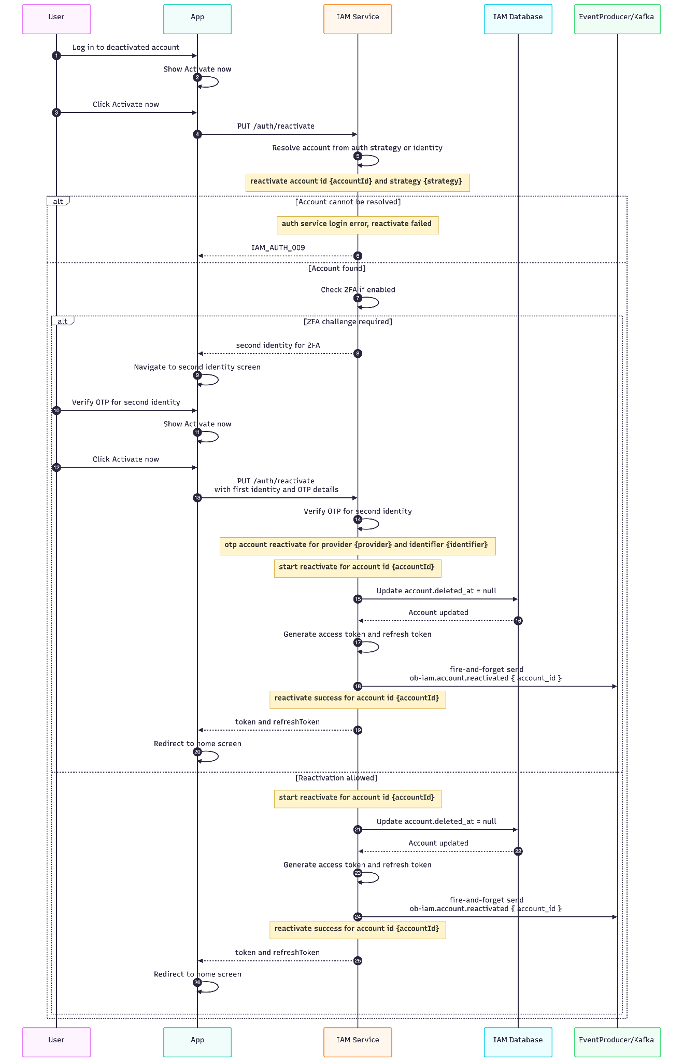

Sequence diagram- SSO
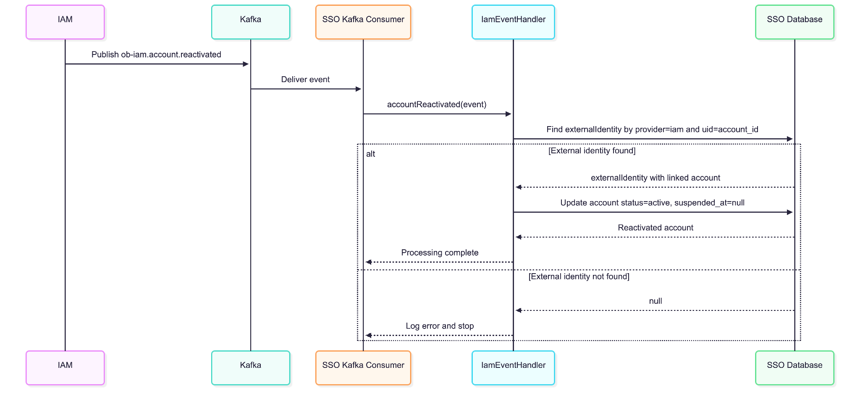

Api description - IAM

Example Request

Password Reactivation
PUT /auth/reactivate HTTP/1.1
Content-Type: application/json
{
"identity": {
"provider": "email",
"identifier": "user@example.com"
},
"password": "example-password",
"device": {
"device_id": "device-123",
"os": "ios"
}
}

2FA Reactivation After Second Identity OTP Verification
PUT /auth/reactivate HTTP/1.1
Content-Type: application/json
{
"identity": {
"provider": "email",
"identifier": "user@example.com"
},
"password": "example-password",
"otp": {
"id": "otp-id-from-second-identity-verification",
"reference": "otp-reference"
},
"device": {
"device_id": "device-123",
"os": "ios"
}
}

Request Body
Field | Type | Required | Description
identity.provider | string | Yes | Identity provider used to resolve the account.
identity.identifier | string | Yes | User identifier, such as phone number or email.
identity.country_code | string | No | Country code for phone-based identities.
password | string | Conditional | Password for password-based reactivation.
device.device_id | string | Conditional | Device ID. Required when device storing is enabled.
device.os | string | Conditional | Device operating system. Required when device storing is enabled.
otp.id | string | Conditional | OTP ID for OTP-based reactivation.
otp.reference | string | Conditional | OTP reference for OTP-based reactivation.

Kafka Event

Event Name
ob-iam.account.reactivated

When It Is Produced
The event is produced by AuthService.reactivateAccount() after:
- The account has been updated with deleted_at = null
- New access and refresh tokens have been generated
- Required device storing has completed when enabled

Response Format

Success Response
When the account is successfully reactivated:
{
"data": {
"token": {
"value": "access-token"
},
"refreshToken": {
"value": "refresh-token"
}
}
}

2FA Challenge Response
When 2FA must be completed before reactivation:
{
"data": {
"identity": {
"identifier": "user@example.com",
"provider": "email"
}
}
}

Error Scenarios
Error Code | HTTP Status | When It Occurs | User Action
IAM_AUTH_009 | 401 | IAM cannot resolve an account for reactivation. | Confirm the user credentials, identity, or OTP data and retry.
IAM_STT_001 | 402 | 2FA is enabled but the default 2FA identity cannot be found. | Check account 2FA configuration before retrying.
OB_001 | 500 | Unexpected internal failure, including missing device data when device storing is enabled. | Retry the request; if it persists, contact support.

Error Response Examples

401 - Reactivate Failed (IAM_AUTH_009)
{
"error": {
"code": "IAM_AUTH_009",
"message": "Reactivate failed",
"stack": "..."
}
}

402 - 2FA Identity Does Not Exist (IAM_STT_001)
{
"error": {
"code": "IAM_STT_001",
"message": "phone Identity does not exist",
"stack": "..."
}
}

The IAM_STT_001 message uses the missing 2FA provider in the message. For example, it can be phone Identity does not exist or email Identity does not exist.

500 - Internal Server Error (OB_001)
{
"error": {
"code": "OB_001",
"message": "internal server error",
"stack": "..."
}
}

5. Api description - SSO

Kafka Event Contract

Event Name
ob-iam.account.reactivated

Purpose
Synchronize an IAM account reactivation into SSO by activating the matching SSO account and clearing its suspension timestamp.

Event Structure
{
"name": "ob-iam.account.reactivated",
"payload": {
"account_id": "string"
}
}

Payload Details
Field | Type | Required | Description
account_id | string | Yes | IAM account ID. SSO matches this value with external_identities.uid where provider = "iam".

6. Cache keys
Key | TTL | Source | Purpose
IAM_TOKEN_{accountId}_ACCESS | SSO_ACCESS_TOKEN_TTL default 3600 seconds | AuthService | Cached hash of the generated access token.
IAM_TOKEN_{accountId}_ACCESS_JWT | SSO_ACCESS_TOKEN_TTL default 3600 seconds | AuthService | Cached generated access JWT used by token validation/renewal paths.
IAM_TOKEN_{accountId}_REFRESH | SSO_REFRESH_TOKEN_TTL default 86400 seconds | AuthService | Cached hash of the generated refresh token.

